Sequential CQ / HCQ Research Papers and Reports
January to April 20, 2020
Executive Summary Interpretation of the Data In This Report
The HCQ-AZ combination, when started immediately after diagnosis, appears to be a safe and efficient treatment for COVID-19, with a mortality rate of 0.5%, in elderly patients. It avoids worsening and clears virus persistence and contagious infectivity in most cases.

Sequential CQ / HCQ Research Papers and Reports
January to April 12, 2020

22 August 2005
CDC Special Pathogens Branch
MJ VIncet, E.Bergon, S. Benjannet, BR Erickson, Pierre Rollin, T.G. Ksiazek, NG Seidah,
ST Nichole. Chloroquine is a potent inhibitor of SARS coronavirus infection and spread. Virology Journal. (2005) 2: 69
Chloroquine has strong antiviral effects on SARS CoV infection of primate cells in tissue culture. These inhibitory effects are observed when cells are treated with the drug either before or after exposure to the virus, suggesting both prophylactic preventative and treatment use. The paper describes three mechanisms by which the drug might work and suggest it may have both a prophylactic and therapeutic role in Coronavirus infections.

……………………………………………………………………………………….
28 January 2020
M. Wang, R. Cao, L. Zhang, X. Yang, J. Liu, M. Xu, Z. Shi, Z. Hu, W. Zhong, G. Xiao
LETTER TO THE EDITOR Cell Research Remdesivir and chloroquine effectively inhibit the recently emerged novel coronavirus (2019-nCoV) in vitro. Cell Research (2020) 0:1–3; https://doi.org/10.1038/s41422-020-0282-0
Tested Remdesivir and Chloroquine in addition to five other drugs were tested in tissue culture against a clinical sample of virus from a COVID-19 patient, Remdesivir and Chloroquine are highly effective in the control of 2019-nCoV infection in vitro. Since these compounds have been used in human patients with a safety track record and shown to be effective against various ailments, we suggest that they should be assessed in human patients suffering from the novel coronavirus disease.

February 13, 2020
Physicians work out treatment guidelines for coronavirus, Korea Biomedical Review http://www.koreabiomed.com/news/articleView.html?idxno=7428
The Korean COVID-19 Central Clinical Task Force, held the sixth video conference and agreed on treatment principles for patients with COVID-19.

- Young with mild symptoms without underlying conditions, doctors can observe them without antiviral treatment.

- If 10 days have passed since the onset of the illness and the symptoms are mild, physicians do not have to start an antiviral medication.
- If patients are old or have underlying conditions with serious symptoms, physicians should consider an antiviral treatment as soon as possible. lopinavir 400mg/ritonavir 100mg (Kaletra two tablets, twice a day) or chloroquine 500mg orally per day. Alternate is hydroxychloroquine 400mg orally per day.
February 18, 2020.
Jianjun Gao, Zhenxue Tian, Xu Yang Breakthrough: Chloroquine phosphate has shown apparent efficacy in treatment of COVID-19 associated pneumonia in clinical studies. BioScience Trends Advance Publication, DOI: 10.5582/bst.2020.0104
Thus far, results from more than 100 patients have demonstrated that chloroquine phosphate is superior to the control treatment in inhibiting the exacerbation of pneumonia, improving lung imaging findings, promoting a virus negative conversion, and shortening the disease course.
Severe adverse reactions to chloroquine phosphate were not noted in the aforementioned patients. Given these findings, a conference was held on February 15, 2020; participants including experts from government and regulatory authorities and organizers of clinical trials reached an agreement that chloroquine phosphate has potent activity against COVID-19.

27 February 2020
Philippe Colson , Jean-Marc Rolain , Jean-Christophe Lagier , Philippe Brouqui , Didier Raoult , Chloroquine and hydroxychloroquine as available weapons to ﬁght COVID-19, International Journal of Antimicrobial Agents Feb (2020), doi: https://doi.org/10.1016/j.ijantimicag.
2020.105932
following the very recent publication of results showing the in vitro activity of chloroquine against SARS-CoV-2, data have been reported on the efficacy of this drug in patients with SARS-CoV-2-related pneumonia (named COVID-19) at different levels of severity.
Following the in vitro results, 20 clinical studies were launched in several Chinese hospitals.
The first results obtained from more than 100 patients showed the superiority of chloroquine compared with treatment of the control group in terms of reduction of exacerbation of pneumonia, duration of symptoms and delay of viral clearance, all in the absence of severe side effects. This has led in China to include chloroquine in the recommendations regarding the prevention and treatment of COVID-19 pneumonia.
Chinese teams showed that Chloroquine could reduce the length of hospital stay and improve the evolution of COVID-19 pneumonia, leading to recommend the administration of 500 mg of chloroquine twice a day in patients with mild, moderate and severe forms of COVID-19 pneumonia.

4 March 2929
Philippe Colson,^{a,b} Jean-Marc Rolain,^{a,b} Jean-Christophe Lagier,^{a,b} Philippe Brouqui,^{a,b} and Didier Raoult, Chloroquine and hydroxychloroquine as available weapons to fight COVID-19. Int J Antimicrob Agents. 2020 Mar 4 : 105932. doi: 10.1016/j.ijantimicag.2020.105932 [Epub ahead of print] PMCID: PMC7135139 IPMID: 32145363
A review of the safety and efficiency of CQ and HCQ reviewing more than 20 clinical studies in several Chinese hospitals.
Although only available in letter form, this data caused China to recommend Chloroquine in the National Guidelines for the Treatment of COVID-19.

9 March 2020
X.Yao, F/ Ye2, M. Zhang, C.Cui, R. Lu, H. Li, W. Tan, D. Liu. In Vitro Antiviral Activity and Projection of Optimized Dosing Design of Hydroxychloroquine for the Treatment of Severe Acute Respiratory Syndrome Coronavirus 2 (SARS-CoV-2). 2020.. Clin Infect Dis. 2020 Mar 9. pii: ciaa237. doi: 10.1093/cid/ciaa237.
Hydroxychloroquine was found to be more potent than chloroquine at inhibiting SARS-CoV-2 in vitro. Hydroxychloroquine sulfate 400 mg given twice daily for 1 day, followed by 200 mg twice daily for 4 more days is recommended to treat SARS-CoV-2 infection.

9 March 2020
Expert Chinese consensus on Chloroquine Phosphate for New Coronavirus Pneumonia. Diagnosis and Treatment Plan. Chinese Journal of Tuberculosis and Respiratory Diseases. 2020, 43:
A Multicenter Collaboration Group was formed to guide and standardize the use of Chloroquine in Coronavirus pneumonia, standardizing Chloroquine treatment at 500mg 2x day for 10 days. Use of azithromycin was contraindicated.

20 March 2020
Gautret P, Lagier JC, Parola P, Hoang VT, Meddeb L, Mailhe M, Doudier B, Giordanengo V, Vieira VE, La Scola B, Rolain JM, Brouqui P, Raoult D. Hydroxychloroquine and azithromycin as a treatment of COVID-19: results of an open-label non-randomized clinical trial. Int J Antimicrob Agents. 2020 Mar 20:105949. doi: 10.1016/j.ijantimicag.2020.105949.
Confirmed COVID-19 patients were included in a protocol from early March to March 16th, to receive 600mg of hydroxychloroquine daily and their viral load in nasopharyngeal swabs was tested daily in a hospital setting.
Untreated patients from another center were included as negative controls.
20 cases were treated in this study and showed a significant reduction of the viral levels at D6-post inclusion compared to controls, and much lower average carrying duration than reported of untreated patients in the literature. Azithromycin added to hydroxychloroquine was significantly more efficient for virus elimination.
Despite its small sample size our survey shows that hydroxychloroquine treatment is
significantly associated with viral load reduction/disappearance in COVID-19 patients and its effect is reinforced by azithromycin,

20 March 2020
Mount Sinai health system treatment guidelines for SARS-CoV-2 infection (COVID-19) https://www.mountsinai.org/health-library/diseases-conditions/2019-novel-coronavirus-2019-ncov Last accessed on 20th March 2020.
Mount Sinai Heath System establishes protocols for dosing and treatment of COVID-19 patients using Chloroquine and Hydroxychloroquine.

27 March 2020
P. Gautret, J.C. Lagier, P. Parola, V.T. Hoang, T. Dupont, S. Honoré, A. Stein, M. Million, B. La Scola, P. Brouqui, Didier Raoul. Hydroxychloroquine-Azithromycin Treatment for COVID-19 Shown to be Effective in an 80-Patient Study
IHU-Méditerranée Infection, Marseille, France March 27, 2020
In 80 patients receiving hydroxychloroquine and azithromycin we noted a clinical improvement in all but one 86 year-old patient who died, and one 74 year still in ICU. A rapid fall of nasopharyngeal viral load tested by qPCR was noted, with Virus cultures from patient respiratory samples turning negative in 97.5% patients at Day 5.
This allowed patients to rapidly be discharged from highly contagious wards with a mean length of stay of five days.

10 March 2020
Cortegiani A., Ingoglia G., Ippolito M., Giarratano A., Einav S. A systematic review on the efficacy and safety of chloroquine for the treatment of COVID-19. J Crit Care. 2020 Mar 10;(20):30390–30397.
A review was made of six articles (one narrative letter, one in-vitro study, one editorial, expert consensus paper, two national guideline documents) and these clinical trials done in China.

ChiCTR2000030417 COVID-19 pneumonia (n = 30) Chloroquine phosphate
ChiCTR2000030054 COVID-19 pneumonia (n = 100) HCQ 0.2 g BID × 14 days
ChiCTR2000030031 COVID-19 pneumonia (n = 120) 400 CQ BID 2 tablets placebo BID
ChiCTR2000029992 Severe COVID pneumonia (n = 100) CQ 1.0 g × 2 days, then 0.5 g × 12 day
HCQ 0.2 g BID x 14 days
ChiCTR2000029988 Severe COVID-19 pneumonia (n = 80) CQ Standard Rx -Clinical Recovery
ChiCTR2000029975 COVID-19 pneumonia (n = 10) CQ inhalation aerosol
ChiCTR2000029939 COVID-19 pneumonia (n = 100) CQ Standard treatment
ChiCTR2000029935 Single-arm clinical trial (n = 100) CQ No comparison
ChiCTR2000029899 Mild COVID-19 pneumonia (n = 100) HCQ: 6 tablets (0.2 g/ 6 tablets/day
ChiCTR2000029898 Severe COVID pneumonia (n = 100) HCQ Hydroxychloroquine 2 tablets/day
ChiCTR2000029868 COVID-19 pneumonia (n = 200) HCQ Standard Rx Viral test
ChiCTR2000029837 Mild COVID-19 pneumonia (n = 120) HCQ tablets and placebo BID
ChiCTR2000029826 Critically ill COVID-19 pneumonia (n = 45) 2 tablets CQ BID- placebo BID
ChiCTR2000029803 Close contacts with confirmed (n = 320) HCQ- high dose
ChiCTR2000029762 COVID-19 pneumonia (n = 60) HCQ Standard treatment
ChiCTR2000029761 COVID-19 pneumonia (n = 240) HCQ Medium-dose group:
ChiCTR2000029741 Mild COVID-19 pneumonia (n = 112) CQ oxygen index during treatment;
ChiCTR2000029740 COVID-19 pneumonia (n = 78) HCQ 0.2 g BID Lab testing
ChiCTR2000029609 Non-randomized controlled trial (n = 205) Mild-moderate CQ group: CQ plus Lopinavir/ritonavir; Severe CQ
group; Severe Lopinavir/Ritonavir group:
ChiCTR2000029559 COVID-19 pneumonia (n = 300) Group 1: Hydroxychloroquine 0.1 g oral BID; Group 2:
Hydroxychloroquine 0.2 g oral BID Placebo control group: Starch
ChiCTR2000029542 COVID-19 pneumonia (n = 20) Oral chloroquine 0.5 g BID for 10 days 30-day specific mortality
NCT04286503 Critically ill COVID-19 (n = 520) Carrimycin, lopinavir/ritonavir or Arbidol or CQ

- Chloroquine seems to be effective in limiting the replication of SARS-CoV-2 in vitro.

- There is rationale, evidence of effectiveness and evidence of safety from long-time clinical use for other indications to justify clinical research on chloroquine in patients with COVID-19.

- Safety data and data from high-quality clinical trials are urgently needed.

21 March 2020
Duan YJ, Liu Q, Zhao SQ, Huang F, Ren L, Liu L, Zhou YW. The Trial of Chloroquine in the Treatment of COVID-19 and Its Research Progress in Forensic Toxicology. 2020 Mar 25;36(2). doi: 10.12116/j.issn.1004-5619.2020.02.001. [Epub ahead of print]
Chloroquine is a long-established prescription drug that is often used clinically to treat malaria and connective tissue diseases. The antimalarial drug Chloroquine phosphate which has already been approved is confirmed to have an anti-SARS-CoV-2 effect and has been included in diagnostic and therapeutic guidelines. However, awareness of the risk of chloroquine phosphate causing acute poisoning or even death should be strengthened. The dosage used according to current clinical recommended dosage and course of treatment are larger than that of previous treatment of malaria. Many provinces have required close clinical monitoring of adverse reactions. This paper reviews the pharmacological effects, poisoning and toxicological mechanisms, in vivo metabolism and distribution, and forensic issues of chloroquine drugs, in order to provide help to forensic practice and clinical work

21 March 2020
Chloroquine US prescribing information. https://www.accessdata.fda.gov/drugsatfda_docs/label/2017/009768s037s045s047lbl.pdf (Last accessed March 21, 2020)

23 March 2020
Yueping Li, Zhiwei Xie, Weiyin Lin, Weiping Cai, et.al, An exploratory randomized, controlled study on the efficacy and safety of lopinavir/ritonavir or arbidol treating adult patients hospitalized with mild/moderate COVID-19
doi: https://doi.org/10.1101/2020.03.19.20038984
According to investigators, adding hydroxychloroquine (HCQ), on top of conventional therapy didn’t shorten the time to SARS-CoV-2 clearance in a 30-patient trial. No significant differences were observed across the two arms in terms of the time it took to bring body temperature to normal or the number of patients with disease progression as shown in CT scans.
However, a careful examination of the study reveals a more complicated situation. Most patients in the study's control group were actually treated with other antiviral drugs at the same time, including the HIV combo med Kaletra and the Russian flu drug Arbidol. Most, but not all, patients in the hydroxychloroquine group were also treated with Arbidol. All patients also received interferon-alpha, thereby completely invalidating any assessment of Chloroquine effects.

24 March 2020
Pagliano P, Piazza O, De Caro F, Ascione T, Filippelli A. Is Hydroxychloroquine a possible post-exposure prophylaxis drug to limit the transmission to health care workers exposed to COVID19? Clin Infect Dis. 2020 Mar 24. https://www.ncbi.nlm.nih.gov/pubmed/32211764
PMID: 32211764 DOI: 10.1093/cid/ciaa320
Chloroquine and Hydroxychloroquine are able to inhibit replication at early stages of viral
infection. No similar effect on early phases of Coronavirus infection has been reported for other drugs proposed for SARS-CoV-2 treatment, which are able to interfere only after cell infection.
We believe that hydroxychloroquine can be effective in preventing respiratory tract invasion in HCW and that hydroxychloroquine administration as prophylactic agent could be particularly useful for HCW attending to high risk procedures on respiratory tract in COVID-19 patients.

Hydroxychloroquine effectiveness profile, its ability to inhibit lung viral replication for a 10-day period after only a 5- day cycle of therapy, and the large amounts of knowledge in term of safety deriving from its use for malaria prophylaxis and rheumatologic diseases permit to recommend its pre-exposure or post-exposure use for those performing procedures at high risk of viral diffusion in patients with COVID-19 pneumonia.

26 March 2020
A.K. Singh,, A. Singh, A. Shaikh, R. Singh, and A. Misra. Chloroquine and hydroxychloroquine in the treatment of COVID-19 with or without diabetes: A systematic search and a narrative review with a special reference to India and other developing countries. Diabetes Metab Syndr. Published online 2020 Mar26. doi: 10.1016/j.dsx.2020.03.011
PMCID: PMC7102587 PMID: 32247211
A systematic review of Hydroxychloroquine and COVID-19

7 April 2020
Belgium Task Force Interim clinical guidelines for patients suspected of / confirmed with COVID-19 infection.
https://epidemio.wivisp.be/ID/Documents/Covid19/COVID19_InterimGuidelines_Treatment_ENG.pdf

Based on pharmacokinetic simulations, the recommended dosing of hydroxychloroquine sulphate is 400mg BID on day 1, followed by 200mg BID on day 2-5.
Because of the long elimination half-life of the drug (32–50 days), the duration of treatment should not exceed 5 days to avoid accumulation of hydroxychloroquine concentrations in plasma and tissues, and associated increased risk of toxicity, and because there is no in vitro evidence that longer courses improve drug activity on SARS-CoV-2.

10 April 2020Zhaowei Chen, VJijia Hu, Zongwei Zhang, Shan Jiang, Shoumeng Han, Dandan Yan, Ruhong Zhuang, Ben Hu, Zhan Zhang Efficacy of hydroxychloroquine in patients with COVID-19: results of a randomized clinical trial doi:https://doi.org/10.1101/2020.03.22.20040758
Evidence regarding the in-vivo use of Hydroxychloroquine is limited. In COVID-19 infection. This study evaluated the efficacy of hydroxychloroquine (HCQ) in the treatment of patients with COVID-19. From February 4 to February 28, 2020, 62 patients suffering from COVID-19 were diagnosed and admitted to Renmin Hospital of Wuhan University. All participants were randomized in a parallel-group trial, 31 patients were assigned to receive an additional 5-day HCQ (400 mg/d) treatment, Time to clinical recovery (TTCR), clinical characteristics, and radiological results were assessed at baseline and 5 days after treatment to evaluate the effect of HCQ.

For the 62 COVID-19 patients, 46.8% (29 of 62) were male and 53.2% (33 of 62) were female, the mean age was 44.7 (15.3) years. No difference in the age and sex distribution between the control group and the HCQ group. But for TTCR, the body temperature recovery time and the cough remission time were significantly shortened in the HCQ treatment group. Besides, a larger proportion of patients with improved pneumonia in the HCQ treatment group (80.6%, 25 of 31) compared with the control group (54.8%, 17 of 31). Notably, all 4 patients progressed to severe illness that occurred in the control group. However, there were 2 patients with mild adverse reactions in the HCQ treatment group. Significance: Among patients with COVID-19, the use of HCQ could significantly shorten TTCR and promote the absorption of pneumonia.
Clinical Trial ChiCTR2000029559

10 April 2020
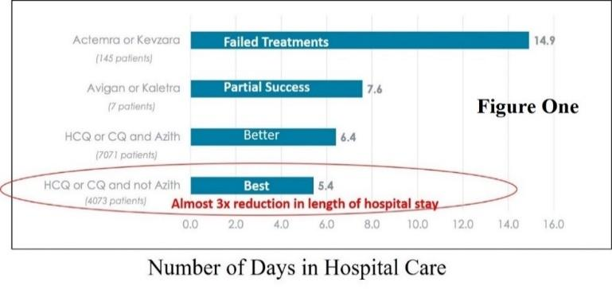
This data is supportive of preliminary evidence suggesting a significant reduction in the average length of hospital stay (ALOS) in COVID-19 patients administered hydroxychloroquine (HCQ) alone.

This crude data was generated by a multi-center data collection effort conducted by Agilum Healthcare Intelligence Inc. based in Brentwood, Tennessee and analyzed with respect to the COVID length of hospital stay under various investigational treatments.
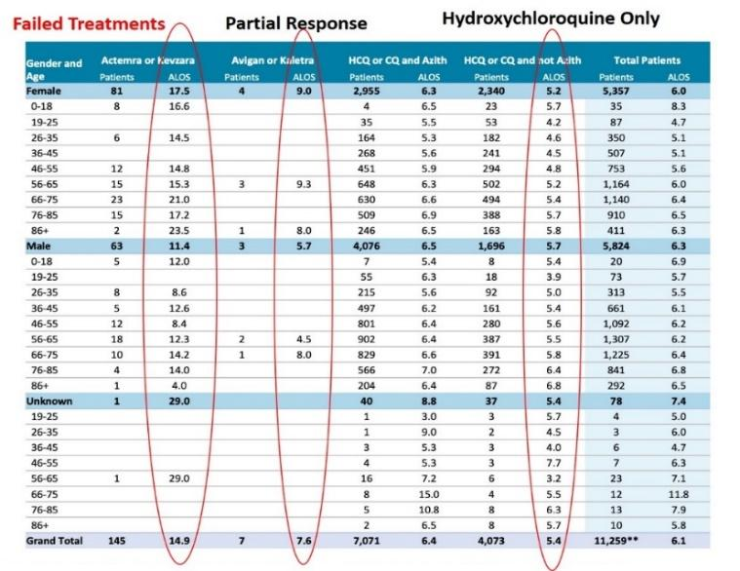

The unpublished data was generated from a bell-curve of patient severities encompassing all levels of severity. Hence, it only provides a gross estimation of a Hydroxychloroquine effect in COVID-19 patients. However it is supportive of the French Data released on 12 April 2020 as an Abstract.

12 April 2020
Raoult, D. Cohort of 1061 COVID-18 cases treated with HCQ-AZ Combination with 9 day follow-up. IHU Méditerranée Infection, Marseille. http://covexit.com/professor-didier-raoult-releases-the-results-of-a-new-hydroxychloroquine-treatment-study-on-1061-patients/
A cohort of 1061 COVID-19 patients, treated for at least 3 days with the HCQ-AZ combination and a follow-up of at least 9 days was investigated. Endpoints were death, worsening and viral shedding persistence. From March 3rd to April 9th, 2020, 59,655 specimens from 38,617 patients were tested for COVID-19 by PCR. Of the 3,165 positive patients placed in the care of our institute, 1061 previously unpublished patients met the inclusion criteria for a Hydroxychloroquine –Azithromycin trial.
Mean age was 43.6 years old and 492 were male (46.4%), As in other studies, no cardiac toxicity was observed in this study.

- A good clinical outcome and virological cure was obtained in 973 patients out of a total pf 1061 patients within 10 days (91.7%).

- Mortality was significantly lower in patients who had received > 3 days of HCQ-AZ than in patients treated with other regimens both at IHU and in all Marseille public hospitals (p< 10-2).

A poor outcome was observed for 46 patients (4.3%); -10 were transferred to intensive care units, 5 patients died (0.47%) (74-95 years old), 31 required 10 days of hospitalization or more.
Among this group, 25 patients are now cured and 16 are still hospitalized (98% of patients cured so far).

Table 1. Baseline characteristics according to clinical and virological outcome of 1061 patients treated with HCQ + AZ ≥ 3 days at IHU Méditerranée infection Marseille, France with Day 0 between March 3 and March 31, 2020
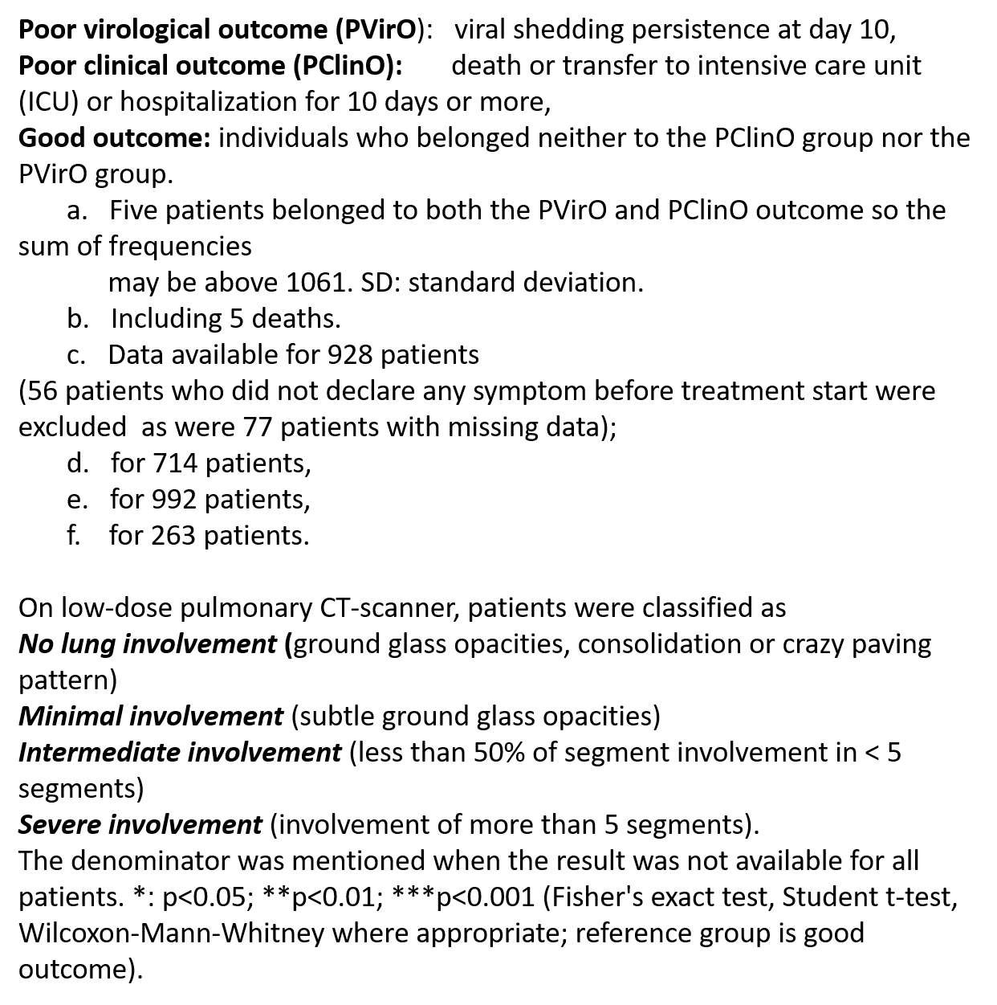
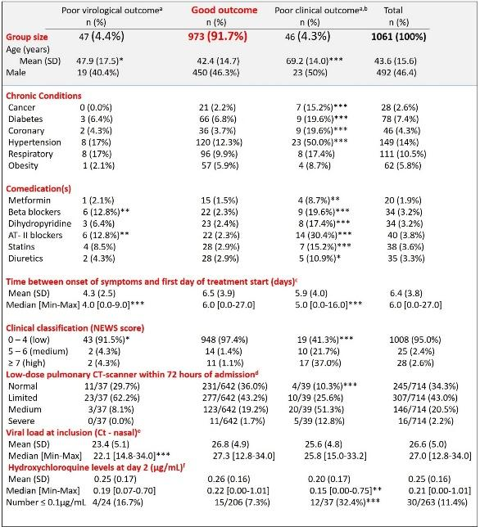
Prolonged viral carriage at completion of treatment was observed in 47 patients (4.4%) and was associated with a higher viral load and more advanced disease at diagnosis (p < 10-2) but viral culture was negative at day 10 and all but one were PCR-cleared at day 15.

Poor clinical outcome was significantly associated to older age (OR 1.11), initial higher severity (OR 10.05) and low Hydroxychloroquine serum concentration.

In addition, both poor clinical and virological outcomes were associated with patients taking selective beta-blocking agents and angiotensin II receptor blockers (P<0.05) for Hypertension.

13 April 2020
J. Gao, Hu, S., Update on use of Hydroxychloroquine to TREAT coronavirus disease 2019 (COVID-19).
Increasing evidence from completed clinical studies indicates the prospects for the treatment of COVID-19 by Chloroquine and Hydroxychloroquine (indications Hydroxychloroquine is more effective).
- Chloroquine has indicated its efficacy in mild and moderate COVID-19 cases.
- Chloroquine is superior to Lopinavir/ritonavir in improving COVID-19 lung lesions.
- Chloroquine has demonstrated significant efficacy in returning body temperature to normal.
- Hydroxychloroquine seems more effective than Chloroquine in a French study on reducing the amount of virus in the body.
- Hydroxychloroquine helps reduce the duration of cough, reduce the amount of virus in the body and improve negative lung lesions on X-ray.
- We have already commented on the single paper involving 15 patients subjected simultaneously to Interferon-Alpha, arbidol, and lopinavir/ritonavir in the control group.
In general, completed clinical studies have yielded promising results regarding the safety and effectiveness of Chloroquine and Hydroxychloroquine in the TREATMENT of COVID-19

Summary of Bibliography Review
Dependent upon a successful peer review of the data presented in 1,061 COVID-19 patients, treated for at least 3 days with the HCQ-AZ combination in the French Abstract released 12 April 2020, by D. Raoult of the IHU Méditerranée Infection and a successful review of the 10 April 2020 paper by Zhaowei Chen et.al, ……
………….the use of HCQ-AZ combination when started immediately after diagnosis, appears to be a safe an efficient treatment for COVID-19. It appears to halt respiratory disease progression and length of hospital stay in many cases.
Within the context of an expanding COVID-19 pandemic, it is reasonable to propose the EARLY use of Hydroxychloroquine in attempt to reduce the number of COVID patient hospitalization days, and hence provide an increased rate of patient turnover and a more efficient use of limited hospital ventilators.
The finding in the gross data study done on 10 April 2020 showing a slightly prolonged Average Length of Hospital Stay (ALOS) in the population group given HCQ/CQ/Azithromycin, requires further investigation. Azithromycin can show the same cardiac conduction effects as Chloroquine in humans, but there has not been a widespread aversion to its being prescribed. Some 4,000 individuals have now been given what are considered to be COVID doses of Hydroxychloroquine, and not one cardiac conduction problem has been noted.
Opinion
Historical controls are used in many previous studies in medicine. In this respect, the safety of Hydroxychloroquine is well documented. When the safe use of this drug is projected against its apparent effect of decreasing the progression of early cases to ventilator use, it is difficult to understand the reluctance of the authorities in charge of U.S. pandemic management to recommend its use in early COVID-19 cases. The effects of the chloroquines were first outlined 15 years ago by the CDC’s own Special Pathogens Unit.

