Haut du formulaire
Search
Bas du formulaire
Friday, 1 August ,2025 inlcome!
A password will be e-mailed to you.
- Defend Democracy PressTHE WEBSITE OF THE DELPHI INITIATIVE
Accueil
- Défense
Article premium,Réservé aux abonnés Le marin

L’USS « Gerald Ford », porte-avions américain de dernière génération, attendu en escale à Marseille
L’ « USS Gerald Ford », fleuron de l’US Navy, va faire escale à Marseille une semaine, a appris « le marin ». Une première pour cette nouvelle génération.
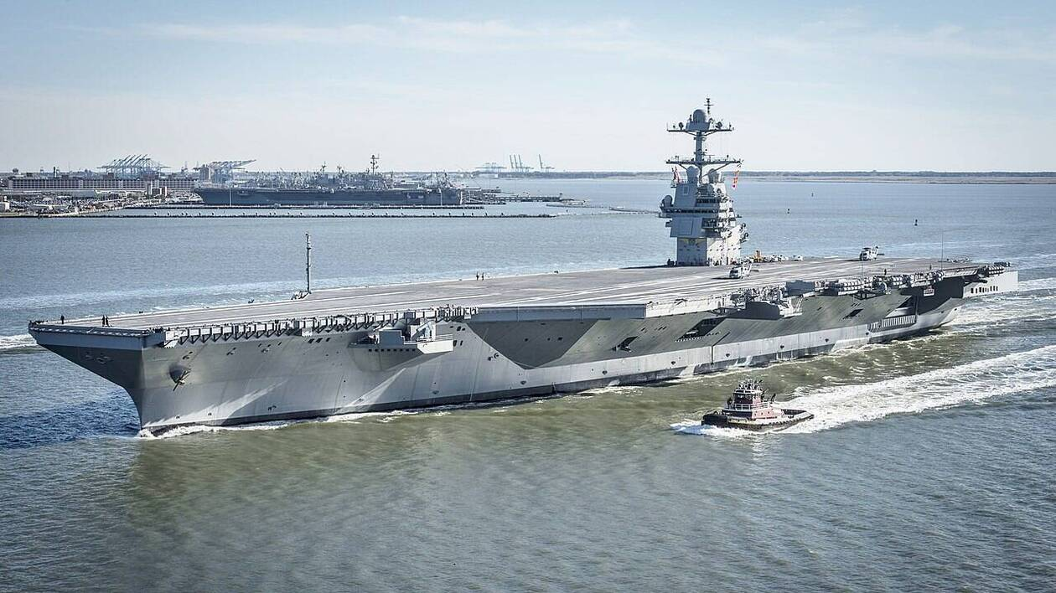
L'» USS Gerald Ford » est un porte-avions de 100 000 tonnes à propulsion nucléaire. | US NAVY
Le marin
Thibaud TEILLARD.
Publié le 31/07/2025 à 17h46
Lire plus tard
Partager
Newsletter Défense
Chaque mardi à 8h : les temps forts de l'actualité de la défense par Denis Blin, journaliste spécialiste Défense au marin

L’USS Gerald R. Ford, porte-avions qui déplace 100 000 tonnes avec sa propulsion nucléaire, est attendu à Marseille du lundi 4 août au samedi 9 août, a appris le marin. Le bâtiment avait quitté Norfolk, le grand port militaire de Virginie, le 24 juin en vue de passer plusieurs mois en Méditerranée orientale et au Proche-Orient.

- Home
- Middle East

Arab states call on Hamas to ‘disarm,’ give up governance in Gaza
31/07/2025

JUL 30, 2025
The Arab League, Turkiye, and the EU have backed a declaration calling for a path toward a two-state solution and an end to the war in Gaza
Arab League nations and Turkiye issued a joint statement at the UN session in New York on 29 July, calling on Hamas to disarm and give up governance of Gaza.
The UN meeting began on Monday, framed as an effort to revive the idea of a two-state solution.
“In the context of ending the war in Gaza, Hamas must end its rule in Gaza and hand over its weapons to the Palestinian Authority, with international engagement and support, in line with the objective of a sovereign and independent Palestinian State,” said a joint declaration signed by 17 countries, including the EU, Turkiye, and Arab states.
We condemn the attacks committed by Hamas against civilians on the 7th of October. We also condemn the attacks by Israel against civilians in Gaza and civilian infrastructure, siege and starvation, which have resulted in a devastating humanitarian catastrophe and protection crisis,” the statement added.
The statement called for an end to Israeli land grabs and settlement expansion in the occupied West Bank, and a return to 1967 borders.
It stressed the Palestinian people’s “right to return” to where they were expelled from during the Nakba in 1948. It also urged the rehabilitation of the Palestinian economy, and the removal of “hateful” material from the Palestinian Authority (PA) education system.
Additionally, it calls on Israel to “issue a clear public commitment to the Two-State Solution, including a sovereign, and viable Palestinian State.”
The session was cochaired by France and Saudi Arabia, and was initially scheduled for June.
France called the New York Declaration “both historic and unprecedented” and called on UN states to support it.
“For the first time, Arab countries and those in the Middle East condemn Hamas, condemn 7 October, call for the disarmament of Hamas, call for its exclusion from Palestinian governance, and clearly express their intention to normalize relations with Israel in the future,” said French Foreign Minister Jean-Noel Barrot.
Saudi Foreign Minister Faisal bin Farhan also called on all states to back the declaration.
Washington and Tel Aviv boycotted the meeting, with the US calling it “productive and ill-timed” and Israel accusing the international community of turning a “blind eye” to Hamas’s “terrorism.”
France announced recently that it will recognize a Palestinian state during the 79th General Assembly session in September.
On Tuesday, UK Prime Minister Keir Starmer said Britain would also recognize Palestine in September unless Israel takes steps toward ending the war in Gaza and reviving the peace process.
Israeli Premier Benjamin Netanyahu said the move would be a “reward for Hamas’s monstrous terrorism.”
Tel Aviv has been threatening recently that international recognition of Palestinian statehood will be met with an acceleration of plans to illegally annex the occupied West Bank.
According to Israeli Channel 12 correspondent Amit Segal, Tel Aviv is expected to make a pivotal decision within 48 hours, saying that if Hamas does not release the captives, Israel could proceed with the formal annexation of parts of Gaza.

Read also:
Iranian media describe Moscow agreement “fragile” and “temporary”

According to Israeli law, undoing annexation would require either a supermajority of 80 Knesset members or approval through a national referendum.
Israel has been rapidly expanding settlements in the occupied West Bank under Netanyahu’s government. In Gaza, Israeli forces are moving to take over the strip and forcibly relocating its population.
The Israeli blockade on the enclave has resulted in a total famine. Dozens, including children, have died of starvation in recent weeks.

